Linux Lab #1

Alex Arnold

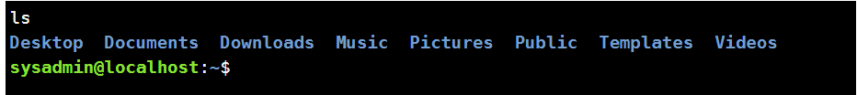

Ls

LS

ls Documents

ls -l

ls -rl

Pwd

cd Documents

cd /home/sysadmin then pwd

su then sl

sudo sl